**Term 3**

**Lesson 5**

**20.10.2021**

**by Beliz Demircioglu**

**Beliz:**

Thank you Berrak, that was such a wonderful way to start. Hi everyone. I would like to start sharing the news with you, if everything goes well, we will be having one more somatic dialogue baby with us in April. I am very excited about that and I wanted to share this with you. And I want to thank Berrak for giving me this opportunity to share my thoughts with you. While we were talking with Berrak, all these things she covered over the last 4 lessons, it is all very deep, and each of them deserves a very long time and I was wondering , what can I bring, that is a bit more different. And we decided, that maybe if I talk about the theory side and philosophical side, where somatic dialogue can be based intellectually. and give some case examples of my work.

A lot of my work is about relational space. I am just going to share a slide with now.

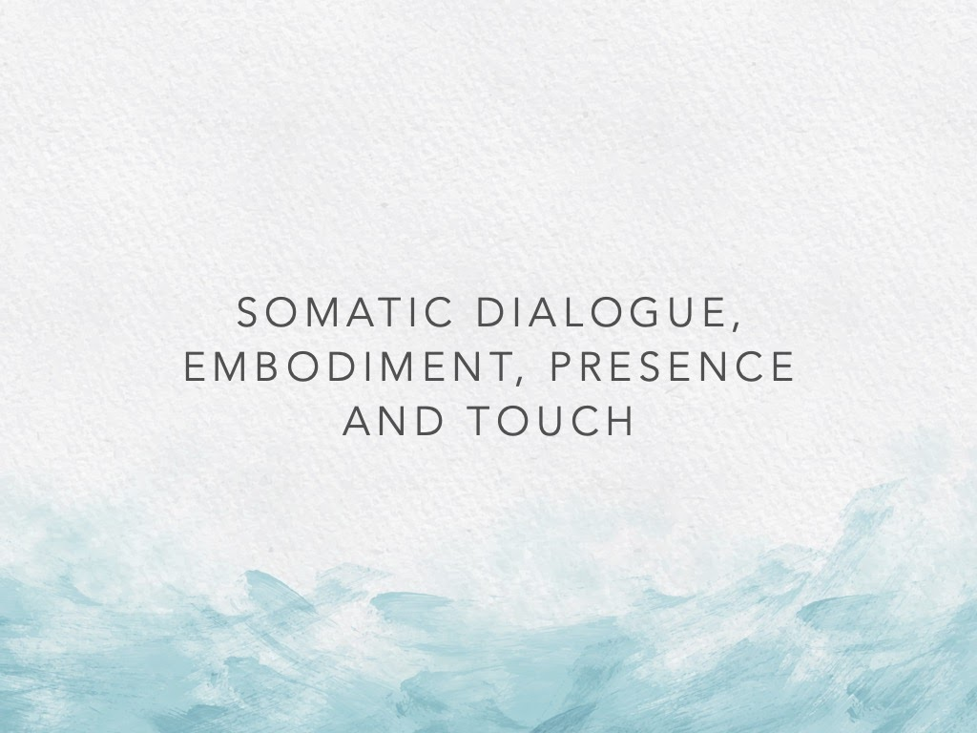

I am going over a presentation, so that you can also see the things that I am talking about.

A lot of my work is about relational space, and I will talk about the relational space inside of us, in between people, and I think that Berrak underlined this a lot, but also in our approach, touch starts way before the physical touch starts. And it starts in this relational space that we have and in order to understand that I am going to try to talk about bigger concepts and then come to Touch.

So I am going to talk about embodiment theory, a little bit of presence and how these relate to the touch.

So if we start from the philosophical side of where Somatic Dialogue bases, I think that one of the philosophers that explain our understanding of the body is Merlea-Ponty, he talks about the lived body. Our lived body is our own uniqueness, each and every one of us, our own uniqueness in perceiving the world. Comes from our authentic bodily experiences, your senses, your understanding, your personal perspective, all this combines into your lived body. And this actually differentiates the objective body. What is the objective body? This mechanical system. the muscles and bones, you have this system that is working. And most of the time, most of the people, some of the western medicine, even and also some of my clients often approach the understanding of the body as this mechanical system.

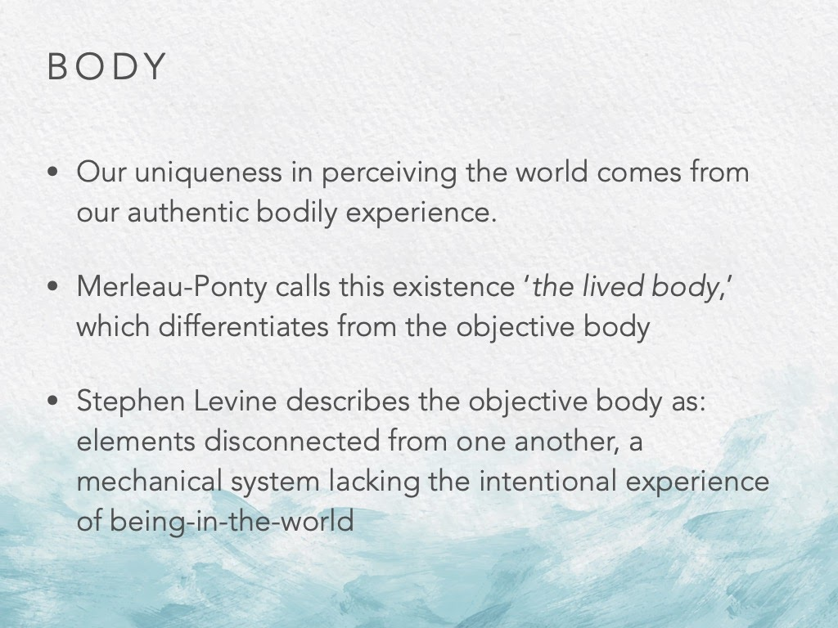

Something is not working, it is just that part that is not working, this not so unique thing. It is really important in our work to look at the body as this, lived body, which in embodiment theory this is described as the 4 layers coming together

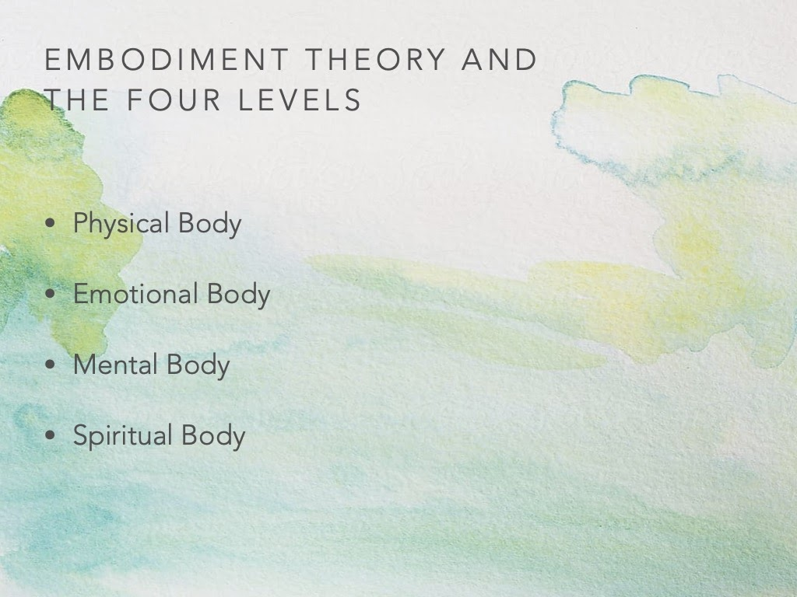

And these four bodies are actually inter-connected, and actually they are always living life in a way together, and they get affected by each other.

How do we work with them? Sometimes we work with different parts and then they affect each other.

When we work with sensations, a lot of our exercises, based on sensations, body postures, the parts, when we talk about proprioception, the parts.. All of these first address the physical body, of course they address the other ones also eventually, but first these exercises work on the physical body.

When we work on feelings, when our clients are working with feelings, it’s the emotional body, and then when we have imagery, memories coming, when the client is having associations coming in, this is actually the mental body being activated.

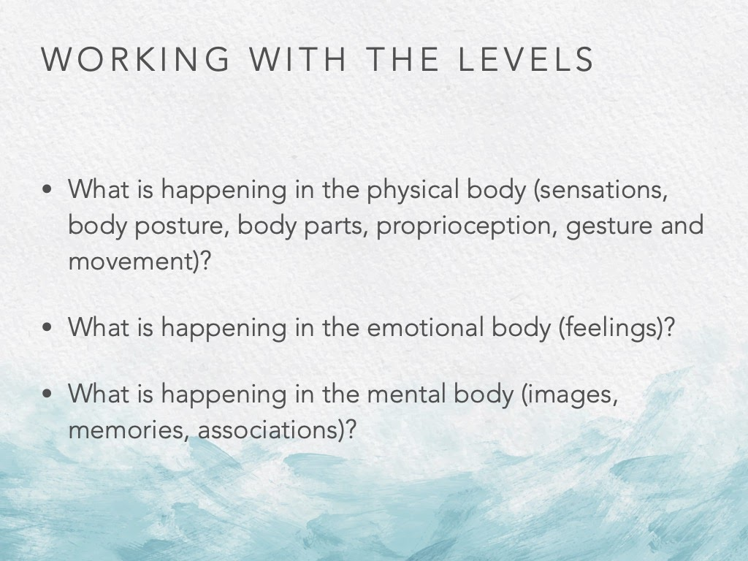

And I would like to give a personal example:

When I was 13, I don’t have a memory of this, I was crossing a street and I looked to the side and a car was coming, the driver instead of pushing the brakes she pushed the gas. She crashed into me, I hit her window and as she was coming really fast I fell back on the pavement, my spine and my head hitting the pavement. So I don’t have any memory of this, and I don’t have a memory of a certain part of my life, due to this. I had a lot of things happening to me, I lost my vision for some time, there was a lot of swelling in my brain, and physical parts in my body, especially my head and parts of my spine were heavily damaged.

so…it took me the first breath that I was able to take through my nose was when I was 22. So it took me years of therapy, surgeries to get to this place. But I was lucky that I was working with the body and I was working with improvisation, a lot of emotions, feelings and images would come in a certain way and I would be able to work with this trauma. I was just able to work with it. Because I didn’t have a memory of what had happened, the images were coming slowly. And I was feeling, but I can say now that in the past years nothing of that trauma has been coming back, but then in few moments, three years ago, when I was in Prague and I was having a Rolfing session. And the rolfer was going to do something inside my nose. I had in the past a lot of surgery there, and I was thinking that things might come up but I wasn;t sure. So when she was touching, these emotions would burst into me. That I had not idea where they were coming from and I had no idea how to deal with them. And she told me that this might happen, and she warned me that we could stop and the go back again, and then stop  etc. And there were sometimes images coming, and or colours coming, and it would just hit me and the emotions were coming down and over me, and after a while I asked her to stop. But basically what happens when we are working with the levels, is that we are never just in one. They are always kind of working together. Which is actually quite productive, and that is what we want.

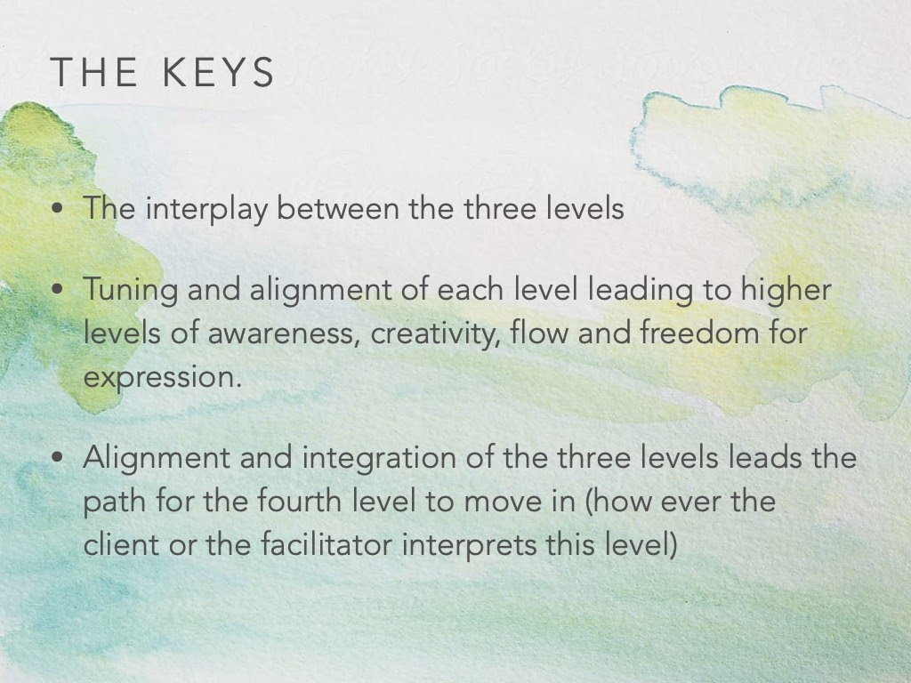

So the interplay between the levels, especially, between the three levels.. because the fourth one, I will explain.. is a little bit different. So when there is an interplay between the three levels, the body releases the trauma in a very positive way.

While we work with the Somatic Dialogue, I think, the tuning and alignment of each level  (the physical, emotional and the mental), .. actually when we work with these levels, the fourth level automatically is working. because it is always inside. THe client or you may call it in a different way, because a lot of people believe in different things, and it is this spiritual level to which we put different words to . But we don’t address the spiritual level directly. That part actually moves within all of these levels that move, and what we are trying to get to : to come to an awareness where there can be creativity, flow and freedom for expression in all of these layers, and there is interaction in between them. Because you will probably know it yourself.. I know it from myself that sometimes I am more in a mental place, sometimes my emotions take over and I am more in an emotional space, so what we are trying to do is actually align them and tune them to each other and to us in general.

One of the cases I would like to talk about is Case S… A client in somatic dialogue that I had worked with. Someone new, With whom I hadn’t worked for a long time, but he was someone who was used to this kind of work, very open. For him I gave him an image to work with, at that point I thought it would be good for him to work with that image. And he took it, and as he was doing the exercise, I saw that something shifted, and he was diving deeper into the exercise, he was doing what I had asked him to do physically, but he was diving much deeper. And when he finished we talked about what had happened. He said he had started with the image, but when he approached the image to his body, the body started to change this image, not to a point where he would change the physical exercise, but to a point where his physical body and the mental body, the imagery, would be working very well together for him in that moment. Which is great, because this is attunement, this is then really personalising what is happening. And not shifting and going to a comfort zone, and remaining in only the physical level of what you are doing.

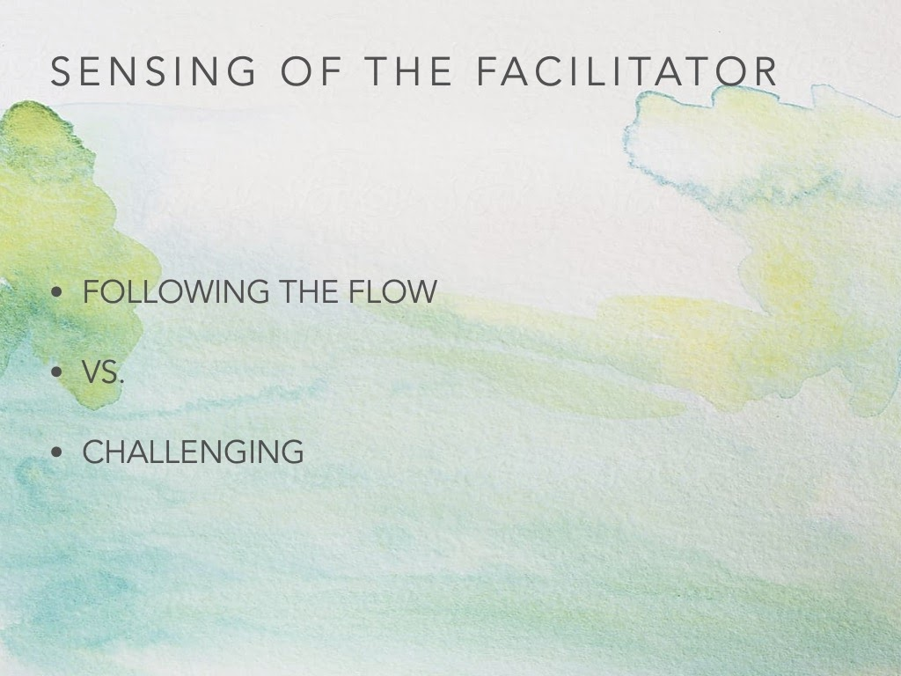

So when we are doing this as a facilitator, working with people.. I think that, one of the ways that comes up is that we follow the flow, we really see the person, where they are and we lead them exactly to where they are going. But not always, sometimes we challenge them. Because we see that the challenge can bring something, that something can take them into another place. I will explain this through another example:

Z was someone, a professional dancer, with whom I had been working for a long time. Technically she has a very high level of movement. That day, she came in. I could see that something in her spine was rigid, but in our talk session, in the beginning of the session, she was completely fine, she was feeling good, and that everything was well. But for me something was off. So we started moving. we started on the floor, without me touching them. she started moving, and I could see that she was flowing but she wasn’t really deep in her body, she wasn’t really letting go and she was faking the movement. And she was a good faker. So I was asking her to become smaller and slower, and I wanted her to realise that she was doing this, and it wasn’t happening. So I asked her if we can sit down and be face to face, I did this exercise, when we sit together and we touch our hands, and one person speaks and the other listens, I asked her to close her eyes in order for her to realise what was happening in her spine without seeing. I wanted her to have a real physical experience of it. So she spoke/danced, I listened. She didn’t realise. She was completely moving from her peripheral, she was not moving from her spine at all. So I asked her to switch roles, she was listening to my movements, and I also asked her if she feels that anything changes during this, she would tell me. Still eyes closed. So I started feeling really my spine, my connection to the floor and feeling my arms, and in the middle of the music I switched only to moving from my arms, and not being connected to the spine. And I asked if she felt if anything had changed. Her spine was so blocked, especially for a professional dancer, her spine was so blocked, that she said that she felt no difference. So we did it again. ANd I knew that when she would see it, she would understand it. But if she saw it, I knew that it was going to be such a shock, and it would scare her.. how can she not feel it. So I asked her that we will do it again, but this time she would look at me. And when she saw that I was not moving from my spine and that it was just from my hands, she really got scared, and said, how can I not feel it all the while I can see it? And she knows this usually. So I said, don’t worry, I know that this is scary, but now you are aware of it, and now we are going to go back to the floor. We’re going to go back to the very beginning and we are just going to move very slowly and softly. You’re not going to dance, you are just going to move, and concentrate just on the connection inside of you, and so she trusted, and we very able to take baby steps, because of her awareness, she was able to take this challenge, she could be faced with something that would scare her, but she would be ok working on it. We moved, and we finished the session just doing this. And instead of meeting the following week we decided to meet two days later in order to do a follow up. And it really worked for her, and then she was fine.

So how we choose as facilitators, will we follow the flow and what the client is doing or are we going to choose to challenge…I think the thing is how do we decide on that?

And this is all about our presence:

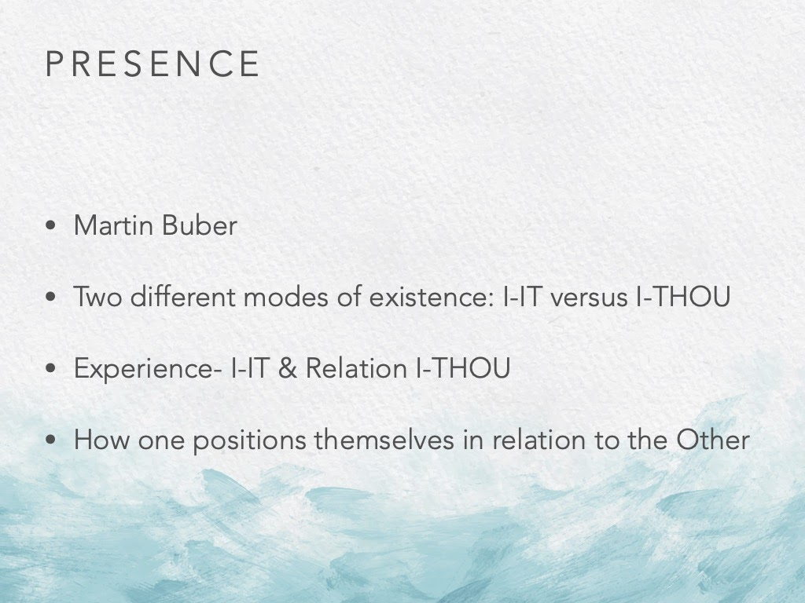

So, with presence, I am going to go back a little to theory and philosophy. I think that one person that you can find interesting and that really relates to our work is Martin Buber. (for the Turkish speakers, I would not recommend the translation) He talks about all of us living our loves in two different modes. He says there are two different modes of existing in this world. And the first one is I-IT, so me and all the other objects, people and things happening are IT.

And the other way of existing is I-THOU.

He says that all of us can live both of them at the same time and switch from one to the other. So the word experience belongs only to the world of the I-IT, and the word Relation only belongs to the world I-THOU. And how we live these concepts depends really how we place ourselves and how we position ourselves in relationship to the other.

So how I take it… we have the power of positioning, and taking our space where we want to stand, and that really defines what kind of an experience or relation we’re going to live.

RELATIONAL SPACE

* Inside and individual
* Between two people
* in a community
* Between the communities

And when I think about this relational space, it can also happen within forces inside an individual. How we judge ourselves, how we love ourselves, all these things in ourselves are our relational space and then how do we position ourselves to the other just as an individual. So how does it happen between two people, in our case with our client and us.

How do we place it in a community, when there is a Somatic Dialogue group class, or sometimes even between communities, this can happen.

OK, so what is it?

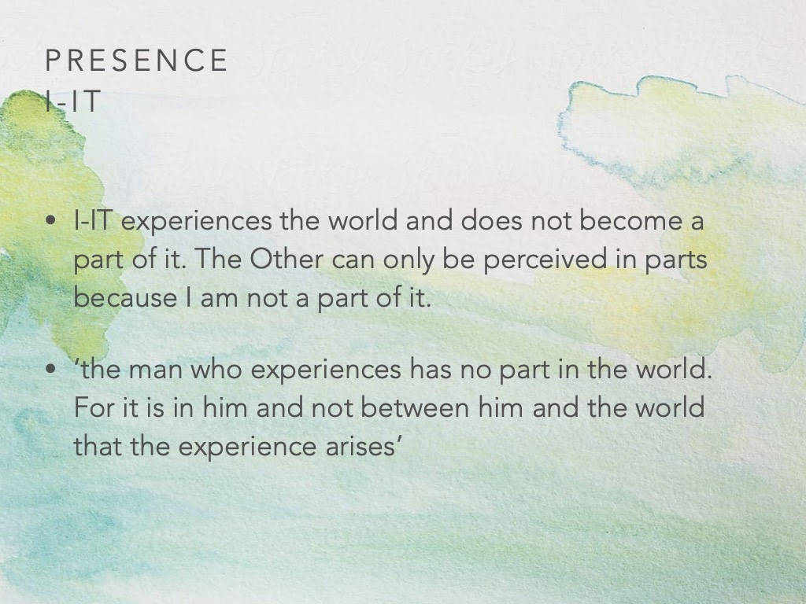

When it is an I-IT,  when I-IT experiences the world, it is not a part of it. We live most of our lives in the I-IT, because what we do is perceive the other from a perspective, so we see it, we perceive it, but we are not a part of it, so we can have a perspective. Which is very valuable, because we need to do this most of the time, we need to live our lives in this mode, because we can’t live all of the time in the I-THOU.

But we shouldn’t forget that when we experience something, we are really not a part of it. So the world is not happening inside of us, and we are getting only a perspective, so there might be many different perspectives according to that.

When it is I-THOU something completely changes:

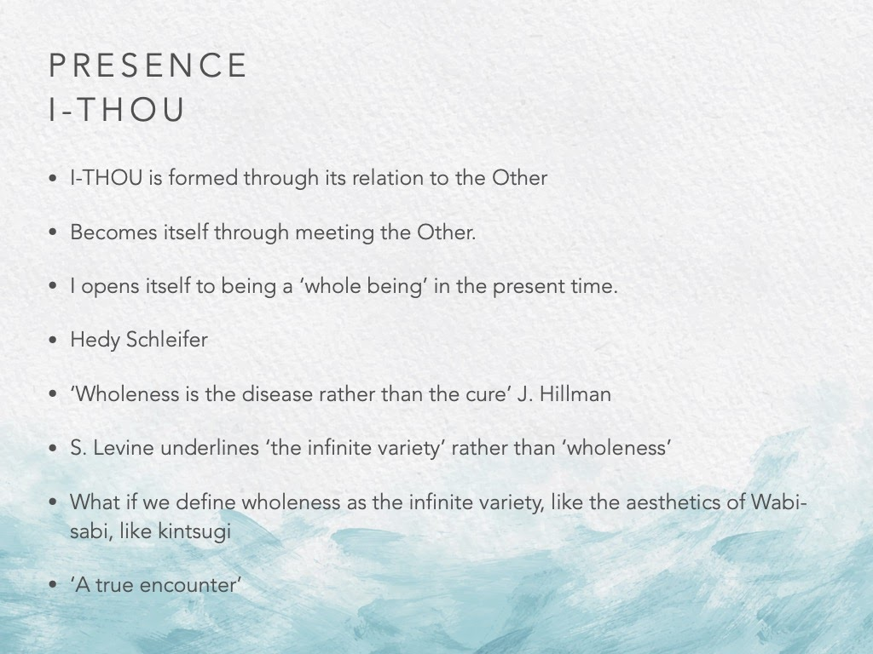

The I-THOU is not something that we experience all the time. Martin Buber says that some people never feel that way. But I am not sure about that…

So I-THOU is formed through our relationship to the other. so when we become ourselves through meeting the other. Because the other is there when we are ther, then we are in an I-THOU relationship. So when I open myself to the other to become a whole being, for this present time, for this amount of time, the two of us meet in this relationship of the I-THOU.

Hedy Schleifer has a very good memory of this, which I would like to share with you. She is a very experienced couple therapist I think. So her mother, ran away from Auschwitz, she just ran away, and she pregnant to Hedy, and this woman, very strong woman, who escaped, and lived her lie in a strong way, very intellectual woman at the end of life gets Alzheimer’s, and for Hedy, this is very difficult to accept her mother in that way. THat her mother is not remembering anything, that she is lost, and whenever she goes to see her mother, she takes all of these thoughts with her: oh she used to be so amazing, and how am I going to reach her now… and all of these thoughts makes the muddy water in between them and she doesn’t really get to see her mother as she is. ANd after a while she reflects on this and decides that she should leave all these things behind, because they are memories she has of her mother, and our relationship together.. but this woman standing here now in front of me, is that person, but also someone else, she doesn’t correspond to these memories anymore. And when she understands this and steps into the relationship, they all of the sudden are able to connect. Other than that her mother doesn’t speak to her. She completely shuts herself off. But when Hedy goes there without the memories, she speaks to her.

So this is the kind of relationship I will talk in detail about. We will really have to be in the presence of,  not bringing our experiences, our knowledge into the present time… bringing it but not being completely affected by it.

So we were talking about being this whole being.. and another person who I enjoy reading is J. Hillman, the psychologist, who talks about very different kinds of theories than regular psychology… So he says: “wholeness is the disease, rather than the cure”

The reason that he says this is, people understand wholeness as something that is pure, that is only one thing, only happiness, or good. And then when they try to reach that state it is not happening, and they have these expectations always, that are really blocking them to really be. And so he says, it is like a disease.

And S. Levine underlines, and he quotes from Shakespeare, and he says what of rather than wholeness we say “infinite variety”, all of us have this infinite variety inside of us.

And for me I think, what if we define wholeness in a different way? What if we make sure we define wholeness with our clients in that kind of way, that there is infinite variety and there is transformation. And that this is possible, and it is not only this or that, and there is this constant change and imperfection. Such as the aesthetics of Wabisabi…it is this line of thought and it basically says that to understand truth you have to look into nature, and when you look into nature, you’ll see that there is imperfection everywhere. Nothing is fully complete, and that’s the beauty of it, the imperfection in the not completeness is the beauty of it. And one of the artworks that I really enjoy is Kintsugi, it is this pottery where you have these broken pieces and there is this gold lining in between them which put the pottery together, and it is the beauty of the imperfection, and the beauty of the brokenness and the acceptance of it, that it really brings it forth. Not trying to hide it but really making something with it.

I think when we approach our work through there, that’s when we have a true encounter with our client. So we meet them, and we meet them everytime, wherever they are that they we meet them anew, all the time.

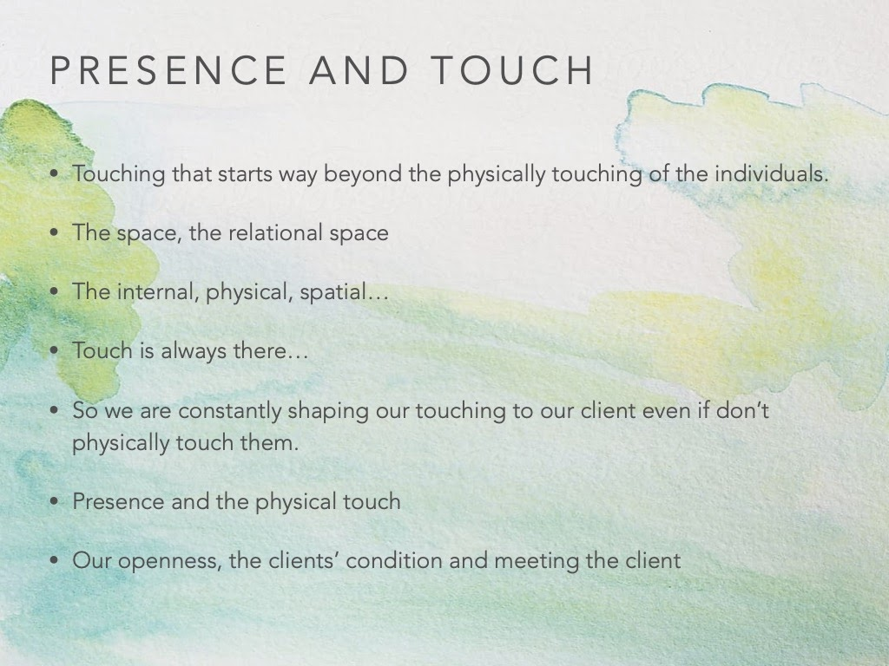

So touching starts way beyond the physical touching. With our clients it starts the first time we speak to them, on the phone, or they send us an email and we reply. or when they walk through the door, really the touching starts there, our words, the space, all of it touch each other, and this defines our relational space with them. And it is like I said, it is the internal space that we are in, it is very important. and we are going to get into that in the next semester. It is very important that our internal space is cleared, possible to receive our client into the space. Our physical space, our physical body is aligned to receive, and for me it is also that space in which we are doing this, whether you are in a studio, or in your home…that place is able to receive someone and touch someone. So we are constantly touching them.

When I realised this, that this touching and this relational space was really there, the presence really made sense, and it sinks into my whole, to all of the four bodies of me.

And then. The physical touch is really magical. And actually physical touch when we are in our mother’s womb is our first sense. It is the first sense that awakens, and for me in Somatic Dialogue, it is almost the last one, when we really touch, and when that happens it is another level. And for me it’s really important that my openness is my responsibility. I think that doing Somatic Dialogue work is a commitment and I take it very seriously. And if I am not really ready, I will have to cancel the session. If I am not really going to be able to be there fully… So my responsibility to a client, to that kind of being, and meeting, is really important.

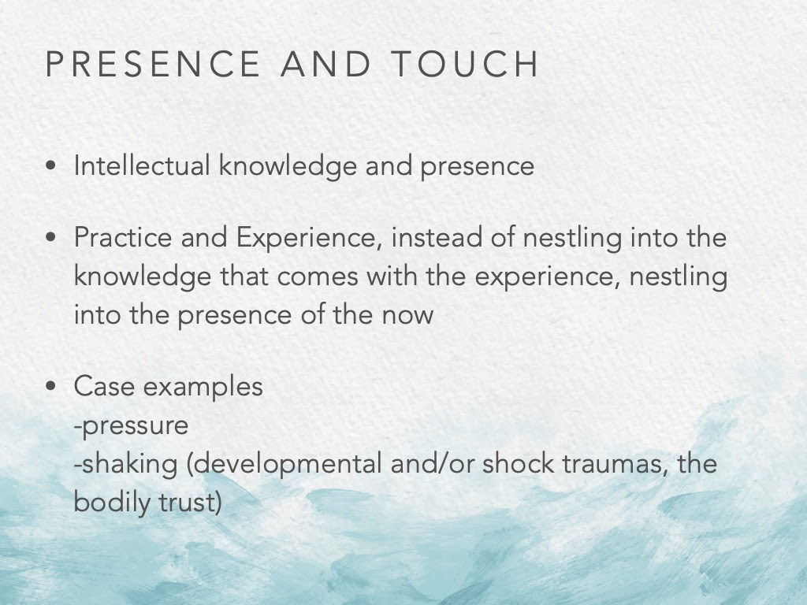

I was talking about our intellectual knowledge, so we get an education, we read, we have experience we do research and all that, which is all very good and necessary, and I also like to read and look into the philosophy of things, but then the presence, in the moment of the presence that intellectual knowledge really needs to step aside for this work. It is good to have it but you have to step away from it. And I will explain why…

This is also true for the practise and experience. As we practise more and more we get this experience which is really valuable because it makes us more sensitive to what is happening there, but at the same time there is the risk of us nestling into the knowledge with the experience, rather than nestling into the presence of the now.

I am going to give you a case example:

There was a client with whom I had been working for a very long time. So I new her very well and basically she was best to work with not such a soft touch but with a touch with more pressure, so that she was really sensing that I was touching her, and this really helped her in many ways. We had been regularly working, and then she was supposed to have internal surgery in one of her organs, it was a planned surgery, something small and not so important. She had this surgery and it was two months that we hadn’t seen each other and then she came for the session. And in my sessions I always take notes, and I always read the notes before the next session. I read her notes and put them aside. We  spoke, but she didn’t say anything about that I should be careful of or anything else.  so we went to the movement part of the session, and for some reason even though I knew that she doesn’t react well to the soft, skin touch, and that she really wants to feel the touch. But for some reason I was touching her even softer, I was barely touching her skin, and I was going over her legs, and it wasn’t even in the torso, where she had the surgery, and there was this thought in me, Why am I doing this although she usually doesn’t like it, but I said OK I am doing this and will see…I will have to let go, because this is what is coming. And then the session finished and we started talking, and it was very interesting for me. She said: I had this experience I need to share with you, before coming here, I thought a lot, because after the surgery there was a very big bloating inside her body, and a lot of pressure she was feeling from the inside towards her surface, and because of this she could not tolerate any kind of touch from her partner even, if it was not super soft. Any touch which was going to the muscles or thein the medium strength she was feeling very uncomfortable with it. So while coming to the session, she wondered if she should says this to me or maybe my touch would be different and she would be ok with that… and for some reason, when you are really present, but also when the client is really present, as in her case, the bodies really speak to each other. So you can’t really go back to the knowledge of your client, you can’t go back to the experience of the session before, or your notes. It is a new place, new person then.

And one more example:

This is very challenging for me… so a client came, this was a client with whom I had worked for some time too, and this kind of client is more challenging. She had developmental trauma, and shock trauma, had been under therapy for a very long time, since she was a kid. And she had a lot of drug therapy that really shifted her ways, and many things had happened to her in her life. And for this person who had been in and out of different therapies, all the time, for almost 20 years, it is very hard for her to trust. It is not something that is in her mind, her mind maybe trusts, I can’t really say for sure, but I had the impression that her mind trusted me in the second month, but it took us 6 months for her body to trust me. But we were at that point, where she could really let go. This is the kind of client that I am talking about, in the time of trust, if you move their session to another day, they have a problem, they are upset, or your words have to be very careful. Because sometimes you may say something, and then they will come back the next week, telling you that what you said stayed with them the whole week… you really need to be gentle and careful in order to build that trust. And the trust is two ways, it is not only that they will trust you but you will have to trust them too. Because you are opening yourself up to be with them. And you need to be careful to know what your needs are to build up that trust in the relationship.

So, we were at that point, we were both feeling that this work was really happening, it was something very productive and was changing things, and in this period one day she came in, and she was not very talkative at that time, and i asked her to lay down, so I started without touching, usually I do that and then we go into the touching sessions. But that day was different, I looked at her and stood beside her, I didn’t open any music, and I put one hand on one place and a finger on another place, and I just lay there beside her, and all of a sudden, this person started shaking dramatically, shaking first slowly but then continued to a full level body shaking.

From my work, I know that shaking for people with trauma is really good, if there is someone with you there, and if you trust that person, and she was really releasing in a full way.

But it is very hard for the facilitator, because you get scared, even though you know, it is very scary to watch someone shaking with their full body. For example, I had the urge sometimes inside to wish for it to stop, or to have this wish to stop them, make them well.. Making them well is our biggest enemy, we can’t make anyone well, but because I was scared while I was touching her, I wanted to make her well.

But that was coming from me, it was about me. So I realised this, noticing this, one of the important keys is, what also Berrak was talking about a lot last week, and you have noticed this also in the workshop, when you work with people standing up with both hands on them, that position, when we need to keep your hips and knees flexible, and feel the floor under our feet, so that the cycle is happening, and the energy can flow through us, so that we are not getting the all the energy fully. The same thing is also crucial and it is sometimes even harder when we are on the floor. So when we are on the floor we sometimes think that this is going to happen, but then we find ourselves a little bit further away from the client, and we are not fully connected to our floor, and when you touch the person you never know how long this is going to last. Maybe you start off with an idea thinking that you’ll change, but that might not happen and you might stay there for 10 minutes.

So you’ll have to start from the very beginning well connected to your spine, and this is what happened to that client of mine… all these fears started coming out, and basically what I could do at that moment, if I would be able to face these fears, I could hold that person in a different way or shift my hands, and then the client would stop the flow, but this was not what was needed with that client at that particular moment. She needed the release, and she could handle the release. So instead of shifting or holding my hands, I was able to let it flow, and let my fears go through into the floor. And one of the key places there are: Berrak was talking about underneath your foot, it is important, and it is also the ankle and the top of your feet, especially when you are in a sitting position. Because everything that flows through your body, released through the feet, through all these parts.

So I held it for some time, and it really worked for us, she was able to release it, and through there we were able to move on to somewhere else.

Moving onto somewhere else:

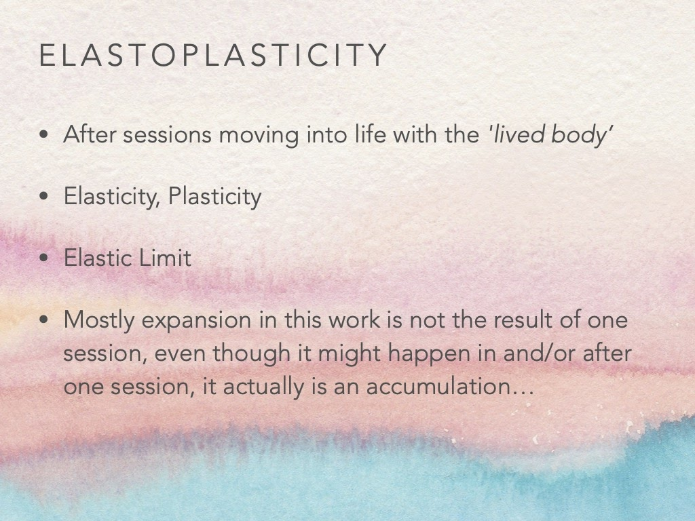

I think that for us, that is also very important. Touch is magical and powerful, that clients might get addicted. And it is our responsibility to help them build a bridge between our sessions and their loves. Help them become independent. To really bond the two.

Because most of the time, when I work with people, the problem that they have is, the session really changes them, but then they cannot keep it in their normal life. So how to help them to keep it in their lives?

This is what happens : because they have had all these sensations, they move in life with the lived body instead of the objective body, which can sometimes be very sensitive, because we really open them up. And before the session ends, we have to help them find the way to close it in a way and then go. And the way I have seen Somatic Dialogue affect people’s life is I say that it is like elastoplasticity:

So when something is elastic, you can pull it, stretch it, and then you release it, and it goes back to its original position.

When something is plastic, when it has the identity of plasticity, if you pull it and then let it go, it stays where it is. so you completely shape its form.

So when you have something that elastoplastic, if you pull it it doesn’t change, but if you pull it further a little above its elastic limit, and then release it, it doesn’t do to its original level, but it doesn’t stay at the point to where you have pulled it, but it goes to somewhere in between.

And I feel this is how Somatic Dialogue is. But it doesn’t happen in one session. It happens in the accumulation of sessions. And even if clients say, now this is the session where everything changed for me, it is actually all the sessions that they have done prior to this session. They have worked up to that session, and then it was the right time for the shift to happen. And in order for that to happen, one of the key factors is for us to have a true encounter. So for us to meet this person, truly in a neutral place of the here and now.

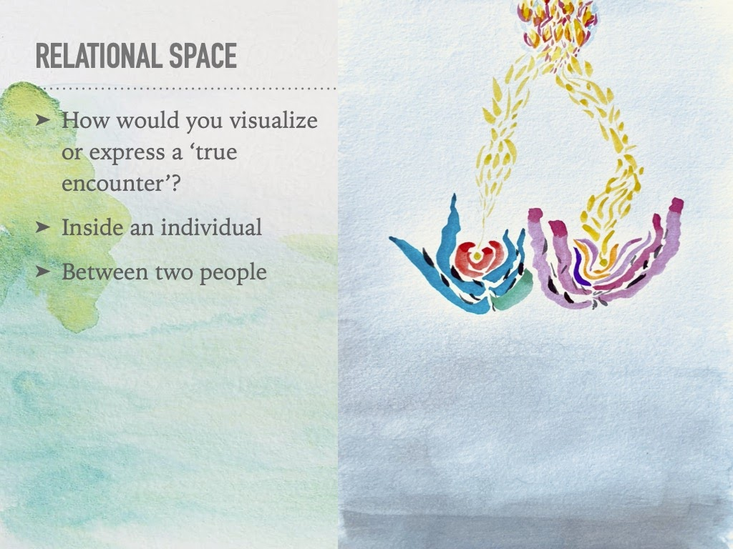

And for me this is something that I do, that really helps me. From time to time, I visualise, or I write down poetry in an artistic form, I express what a true encounter means for me at that time, at that place. Because we always change, I change the clients' change, but then when I see these examples, these expressions, it really has another kind of process in me as a facilitator. Because I find that what is really important for us, is that to think of that touch, touching our soul, our skin, is about doing something with the client, but it is about nurturing ourselves. And if we do not nurture ourselves, then it gets to a point where you get burnt out. it gets really difficult, Ihave lived through it, it is really hard.

So everything that we talk about is a tool for us, because we have to be open for the client, but also for ourselves too. The session is supposed to nurture the client and it is also supposed to nurture us. This is a relationship, it is not a one way street.

This is kind of everything that I wanted to talk about.

Maybe we can have a conversation part right now, we can express how you feel, your experiences…

Katerina: *I would like to ask you, Beliz, if you are letting your clients touch you also, and what this means to you.*

Beliz: I think that’s a great question. Yes I do. I do it a lot. It is this thing about the kind of relationship we build up, as Berrak was saying. At first people tend to think that the work is moving. But when they listen, then it really communicates physically, what we tell them: that listening is important, now they can physically feel it, they listen, you really listen to me, and it also challenges me, which I like too. Because when the work is not fresh, when you are doing so many classes, it is not really refreshing, but when someone is listening to you physically you can also refresh your presence, you feel, am I trying to tell them something? Or am I really here present in what I am doing? Am I trying to cure them, e.g. when they have a blockage in their chest, then I will move my chest in order to show them what to do… so it is a way for us to find our ground and our relationship.

Berrak: *I would like to react to that, I also let me clients touch me a lot, and it is fantastic because even though I can feel their touch is shy, clumsy… because I can feel through their touch what is going on inside of them, if they are listening or not listening at all, but for me it is an invitation to really respond truly to that touch. And not in a way that I am now going to show you how it should be. Sometimes when I feel it is really necessary then I try to show them how it should be, so they can feel it physically. For example, when the shiness is continuing so much while working on the pelvic area, and when they are unable to activate the belly, instead of telling them, I put their hands on me and I do it, and once they feel it they say wow and feel, and they immediately do it, because there is a downloading happening, which is really helping.*

Beliz: Yeah, and this makes me think about the chest, when you work with them and let them touch you in the chest it is problematic. so they touch you near the throat in order not to touch your breast, and you sift their hand down to the right place, and then after a while the hand sifts again up, and you correct it again, and it is a whole process of building the relationship. It is also saying to them, I am trusting you to touch me here, it is really ok. ANd for them it is an adjustment within the session, which changes then slowly.

Berrak: *Yes of course and a lot of our male clients experience this at one moment, and it is also good as it is, because it shows that they react to a touch. But it takes us again to the issue of the sacredness: it helps us to understand: it is sacred but it is not forbidden. The body is something that we all have, and we all have experienced the breast, at least somehow. We all have breasts, and men also have sensitive breasts, for example, I have some male clients that when I put my hand in between their two nipples, I can feel that it arouses them. But, yes it is fine to let this happen, but the body is not a forbidden thing.*

Beliz: I really relate to what you are saying Berrak because it is also, especially with male clients, we end up talking about sexuality, it cime up in the sessions. They either have to stop taking the class, or if I want them to stay, we really need to verbalise this, so it comes to the surface. THis is very normal, it being human and we will go past it, and it will come to another level where we relate as human to human, but right now this is normal. Especially in Turkey, with Turkish clients, ever since they turned teen, and maybe even before, they haven’t experienced touch other than sexuality. And you see another woman touching you, the connection is on that level. And what do we do with that?

Berrak: *yes and as the age advanced it gets more complex. When they are young relatively, through your presence and authority you can calm them down and help them to get over it. I remember in one of my intense workshops at university, I asked them to get into couples before explaining them the task. And then I explained the exercise, and then we had a very good balance of males and females in the class, so there were many mixed couples. And when they heard the exercise, already the blushing started, and then they did the exercise, I could read what had happened. So I asked: “ok who got an erection” and shyly some hands got up, and I asked the girls:’ who got aroused” and of course everyone did and giggling started, blushing etc. And I said: “ look this is great, but if you trust me I can take you somewhere where you can experience ten times greater sensations.” And they just dropped it, the sexual thing was gone, and they remained in the sensuality. You can do this when the group is young, there is less resistance, and they trust you as a teacher, and there is something greater waiting for them, so they go for it. But when you have mature clients, their history, and being one to one, the situation is very different. And this is one of the taboos. This is one of the things that is stopping is accessing to the path of love. Because in the end that is all what we want. Who wants to suffer, when you are with someone. Everyone wants to have pleasure and a good time when they are with someone, right? Nevertheless, it stops us. Especially for us, in this work, to be able to step over it, is very important. We will never solve it. There will be always someone who will attract us. I am also attracted to some clients, it doesn’t matter if they are male of female. But we need to be able to work with that, and most of all we need to be able to verbalise it for ourselves. And realise what is happening in us. That’s why, when we touch, we stick to what we feel when we are touching. We stay in our body.*

Yigit: *Thank you very much for your slides,I loved listening to you and I love it. I have a question…When a client goes into a loop of frustration of the practise, saying: oh it is not good for me, it is not happening. A point where they believe that the method is not fulfilling their expectations, and they go into a cycle of shaming themselves or the method, or blaming: saying: it is not happening, why am I doing this.. did this happen to you?*

Beliz: Do they keep coming to the sessions? or are they quitting?

Yigit: *What would be your approach if a person reacts this way during the session?*

Beliz: one thing important for me is that I have to stand my ground really well. I know that this work really works for me. But this work works if the other person is willing to work with it. It cannot work if they are constantly challenging it. And maybe it is better for them that they don’t do it for some time,a dn then they’ll come back to it. or they should do something else. For example Meditation. A lot of people tend to do meditation in one sitting position, my meditation teacher used to stay, people who have difficulty staying in one position should meditate walking ten steps in one way and then ten steps in another way. And it works. Different things work for different people.

What I would do at that point is that first I would acknowledge that it is not working right now, and I would say: ok so this doesn’t fulfill you right now, we are at a place where this and you are not meeting. Maybe we can try this or that, but it is an option that you need to choose, and I am here to help you up. but it is ok if this is not working for you.

ANd a lot of times people want acknowledgement. Blaming is about them, it is never about you or the work, it is about them. You might be doing something wrong but the key is not blaming the other right? it wouldn’t take us anywhere. so it is about them, and I would try to see where they are and acknowledge that place, and say that it is ok. And then encourage them to make a choice for themselves. There are very interesting people, who say different things. For example I do also expressive arts therapy, and some people can even blame me is saying, how can you charge this for that… people can blame in many different ways. ANd I take supervision and also group supervision and I see how people react. If there is something I need to listen to, take a criticism, or a complaint, I trying to just listen to them and do not comment, and I need to know that I am not pulling them into the work. They have to walk to work, otherwise it is not going to work, and you will get very tired if you pull your clients to work.

Berrak: *And with experience we will learn how to prepare the game. Because standing my ground for me is also being flexible to rebound, that is if something is not working, to let go easily and create a playground in which the client will feel more at ease. And sometimes with some clients you can work towards the issue and sometimes you have to work around the issue. And most of the time, when the clients bring complaints, it is usually related to their resistance. It is their resistance. And if you resist the resistance there is a clash, so you need to step aside and let the resistance go through, and say ok I hear you, and now let’s try this. It really comes with experience.*

Eugenia: *Do you give tips to people when they move, or how they should move, because sometimes they think they are moving from one place, but they are not.*

Beliz: Yes I understand you, this was like one of the cases I talked about, the dancer who was not moving connected to her spine. I was not challenging her at first, I was trying to lead her into her spine, through exercises which would release the spine, but she was really unaware. I tend to, this happens a lot with people who are used to moving. I try to change exercises, to lead them somewhere, where they are blocked. And the pathway with them leads to other places, I can find sessions, when instead of doing the usual stuff, I find myself just touching them for a long time, or doing one exercise that is in the opposite direction of their problem. For example, a lot of people tend to stress the hip flexors, when you tend to tell them to relax their hip flexors, they can never do it because it is very difficult, but if you tell them to relax their sit bones, all of the sudden you see their hip flexors relaxing. So I do these kinds of things.  Or for example, I see a lot of holding in the body, and instead of starting with movement I start with psoas relaxing exercises, for about 20 minutes and ask them to lay there with music, and then their legs are much more there and then we start the lesson.

Eugenia: *Oh I see, because usually I mix a lot of techniques during the lesson and I also teach a lot of gyrotonics. And I touch a lot the people to help them to move, but I was in a festival teaching and I had a lesson which was very free, and I wanted to try Somatic a little bit, and of course I did a little bit of exercise but first I was looking to the people to see what they can, and so it was a very free class, and I was doing a little bit of Somatic but when I saw they had some problem, I thought ok, so I will change the exercise and will do something for that. And then I came back to other exercises of Somatic Dialogue and then it was very good, and they were amazed. They were amazed by the sensation.*

Beliz: Yeah, and I think that Berrak would agree, I think that one of the key things about this program is how do you integrate the Somatic Dialogue into your work. /how do you work with Somatic dialogue, that is how your presence is going to work. All your knowledge can get into it, and bring your own interpretation. Using these exercises and mixing it with other exercises, and make it your own. I think this is very beautiful what you are doing.

Eugenia: *Ok, because at a moment I felt that I don’t have the security to give a lesson of Somatic dialogue. I cannot imagine leading an hour-long lesson of Somatic, but doing something like this little by little, mixing exercises and other exercises, is a way to see how it could be, and how people react to it. And they were so happy doing them, and I was even more happy…*

Beliz: Yes for sure it must have been very mutual.

Berrak: *That’s very nice, and I would add something to that. We will look into that in the 4th term. How to build up a class, in different situations and so forth, but also remember that it is sometimes much more effective to do one exercise for one hour, it is really very interesting, because it takes time and the repetition, each time a little different works well, and you can start with something and each time you repeat it you can add a little more thing, and make slight variations. You can also repeat the same exercise inviting the client to focus their awareness on different parts, for example, do it again but be more aware of your feet, and the next time be more aware of your hands, etc. So in the end you do one exercise, and in the end the client has the experience of “oh ok, so that’s it”. For example the starting point of the movement. Where does that movement start in your body? I had a workshop in which the first hour was only based on this. Where does your movement start? And how can you follow that start? And then how can you accompany it, and from there take it somewhere?*

Katerina: *I would like to add that it is really quite simple somehow, and sometimes the clients are waiting for something, or are waiting for you to give the starting point or really trying to go deep and finding a starting point., And sometimes it is just the decision to start. I sometimes tell them that it is their decision to start. That nothing is going to come, that they have to just start somehow. And then we believe that it will go someow. And this can also be a great moment in their lives, because most of the time they are just waiting for something, even if the exercise is the beginning, and sometimes it is really useful for them to say, just start, try, try and see.*

Berrak: *It is great to see that you are integrating the principles into your work, I strongly advise all of you to do that. You are all ready to do that. And even the experienced dance teachers, and if you have the experience of teaching people, why not make a whole hour of somatic? What can you do wrong? Nothing actually.*

Eugenia: *Yeah, for me it was important in the lesson that the people can connect with the sensation, that was the most important in the class. So I was doing all exercises about that connection between the people, so and the spine, how you feel the spine. ANd thank you so much for the lesson, it is great.*

So does anybody have anything else to share?

Lina: *I have enjoyed the lesson very much, and I have a lot to digest, and what was very interesting was the concept of I-It, I-Thou, and I can feel it in me in relation with different people. I can feel myself shifting, how I perceive myself depending on what I am relating to, with every person I feel like a new person, because of how they see me, and how I feel myself in this meeting, and without all these relations, who am I then, and it is interesting to think about. And maybe all of that… I-Thou is very very interesting.*

Beliz: Without and with the relations: who am I? How do I choose? How do I let it be? It is also a permission to be in an I-Thou with someone. So you open yourself to be there, you open your space, and it is a decision, and also with many layers.

Lina: *And also I relate very much to the I-It as well, when I see myself not all part of it, and also I feel it is interconnected, the I-It and the I-Thou, I think it happens all the time. Often I can sense it at the same time. We really can discover ourselves in new ways, when the presence and openness is there from the other side, because then I can open myself too, and I feel it a lot in the partner, if I can see my partner as new we can relate, the relationship doesn’t stagnate. But if I perceive the other person from the history, something stagnates in the relationship and it is valid for all forms of relationship because we change every time, and with our mothers and children, it is difficult, because we such a long history of bonding, and then to keep the aliveness relating fresh… and with the clients it must be similar thing.*

Berrak: *But first you need to relate to your body on a daily basis, because we work and we access the physical, emotional and mental level through the work of the body, and if we are not able to decide to approach our own being freshly everyday it will not work, so first to have this fresh relationship to ourselves, being challenged by the change, being challenged by the work that we do, because each work and experience transform our relationship to our body. When you rehearse for something for a long time, you are shaped by what you are doing. And then when you stop working, you are shaped by what you are doing, and all the emotional experience will shape how you will relate to your weight, to gravity and we are not machines. So we need to have this mechanism in us, so that we can refresh ourselves everyday. And of course with the client, with the dance partner, with our child… but if we work on this ourselves, then automatically your attention is not any more on the history. It is when you don’t work on this, your history is catching you, your judgments catch you. And that is the good thing about this work, that is why I am insisting on discipline, because while you are working on this, you spend your energy and time on something productive for yourself, instead of thinking of the past for example.*

Beliz: Yeah and that really relates to touch, because I think a lot of the time the feedback that comes from the students and also from clients, is that they find themselves when they  touch you, how their touch is going to make you feel. As if they have that kind of knowledge about how you feel, but it is not possible, even for us to know what our clients feel…we are really supposed to practise staying in us and being in relation to the other and not wondering how it is communicating to the other constantly. But that is the practise and for me it took time. We are so programmed to think that way, so it took time for me to really stay there, and work a lot with myself, so that I am not thinking how they would feel about the touch.

Berrak: *Yeah, that shift is crucial.*

Beliz: It really changes the way the person you move with feels also, they really feel when you are thinking about how they will touch. This happens with clients, when they do it and then they say, oh I was thinking about how this would do you good, or if it is good for you, or this kind of thing, and you can really feel it, the experience really changes. Because then they are not really there, and there is not this sharing of the experience.. But it is a whole process of working towards this. But for us it is really important that we practise this so much that we get tired of it and get it out of our system, so that we do not worry about how the other is going to feel.

It keeps coming back but then, we have to work on it again…

Berrak: *It is a constant work actually.*

Beliz: And also the beauty of it, because there is nothing lively and fresh in when you think you are done.

Berrak: *Would like to explain the assignment shortly for the next time?*

Beliz: What I was going to ask was, that sometimes understanding a concept, developing its meaning in you I think, maybe researching a concept in you, finding different meanings for it. What I find is that when you work with different artistic modalities, different perspectives come up. So you make something visual, it can be a sculpture, with what event you have, you don’t need high skills for this, or you can write a text or poetry, or if you try this with movement, the concept really opens itself in different ways to your understanding. So I was going to ask you to explore whatever true encounter means right now at this moment to you, how does it look, how does it smell, how does it show itself in colours in shapes… I was going to invite you to share this experience. And then maybe we can talk about it and we can see each other’s paintings, to see how different versions are possible to exist. In order to inspire each other in certain ways.

Berrak: *So maybe it can be as an assignment over the week, and then we start a session with that. It can be a nice homework to do over the week.*

Beliz: And as much as you can try not to think about it, just see what paints pull you, and just explore, the only thing the only limit you have is about a true encounter, it might be the forces inside of you, you with the other, however you wish.

Thank you everyone, for being so here with me, it was a pleasure to be together with you.